New Navigation System 20 points Total: 20 points
Move around the world with arrow keys
Move camera angle with wasd (a,d changes theta) (w s changes phi)
Zoom in/out with - =
Ride Coaster with tab

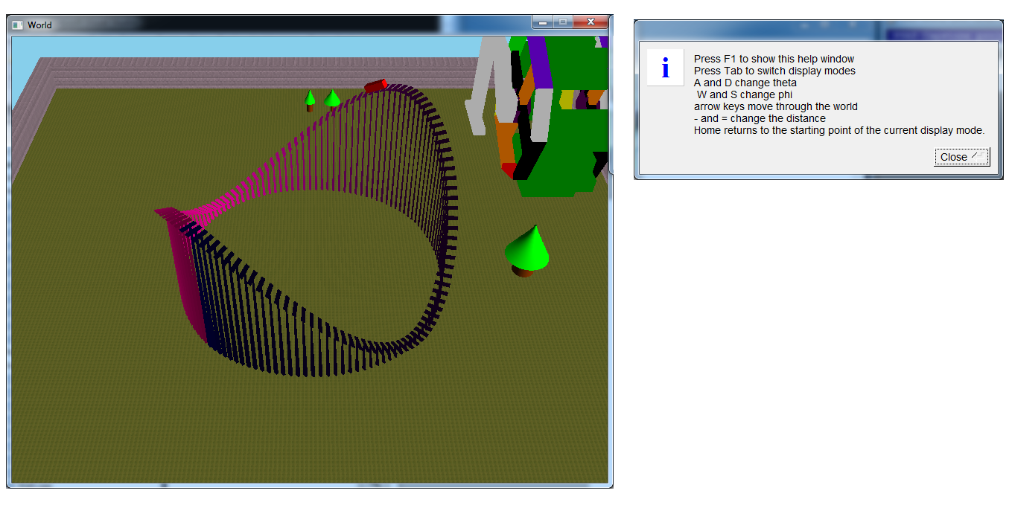

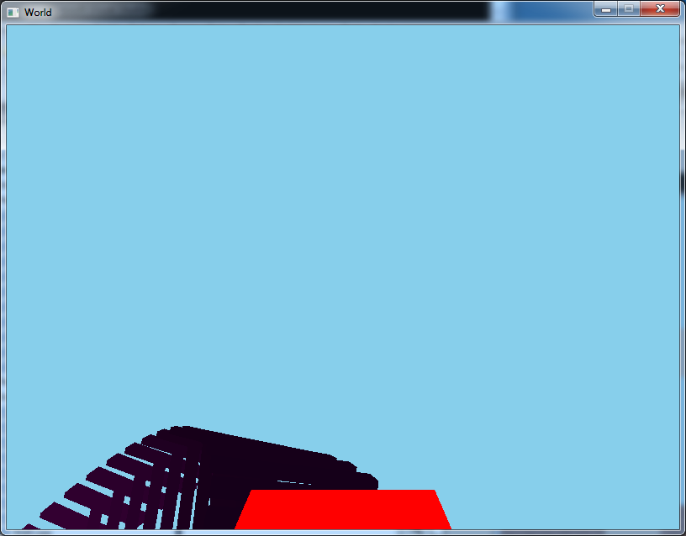

Sweep Object 25 Points Total: 45 points
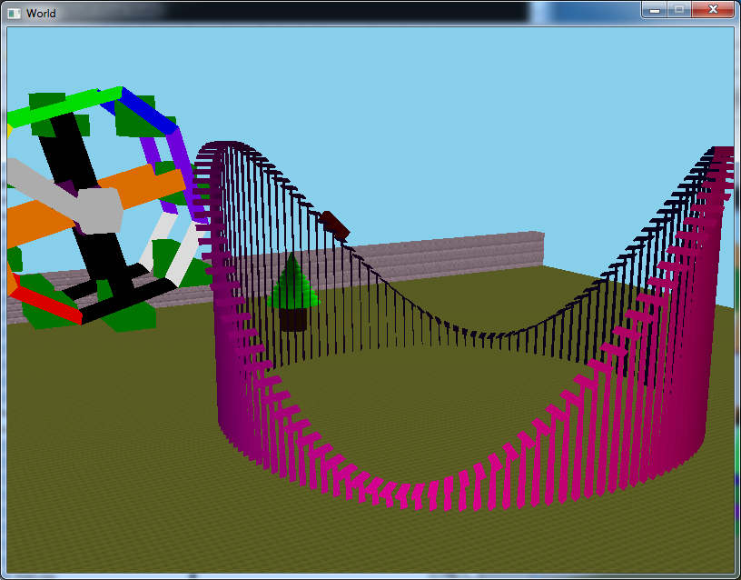

Paramatric Instancing 20 Points Total: 65 points
Tree with parameters for cone and cylinder height,diameter
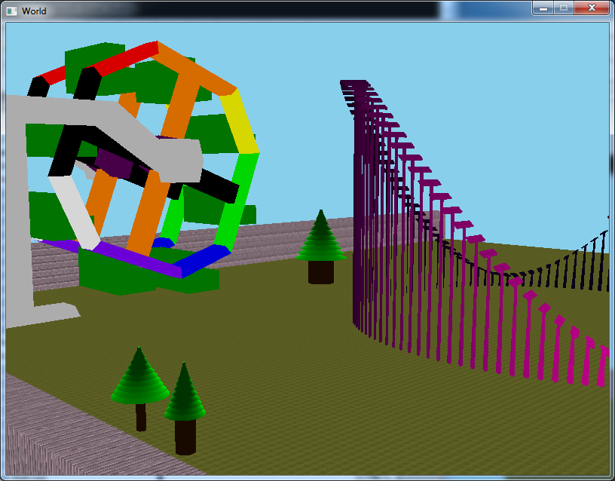

Hierarchical Animated Model 25 Points Total: 90 points
Animated Ferris wheel with child seat models
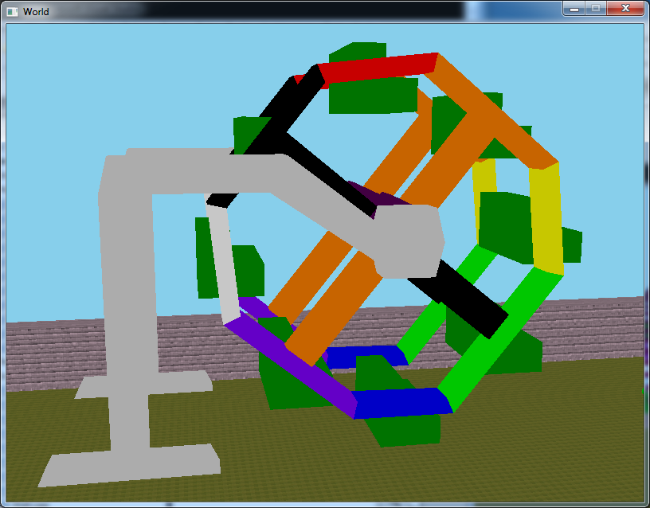

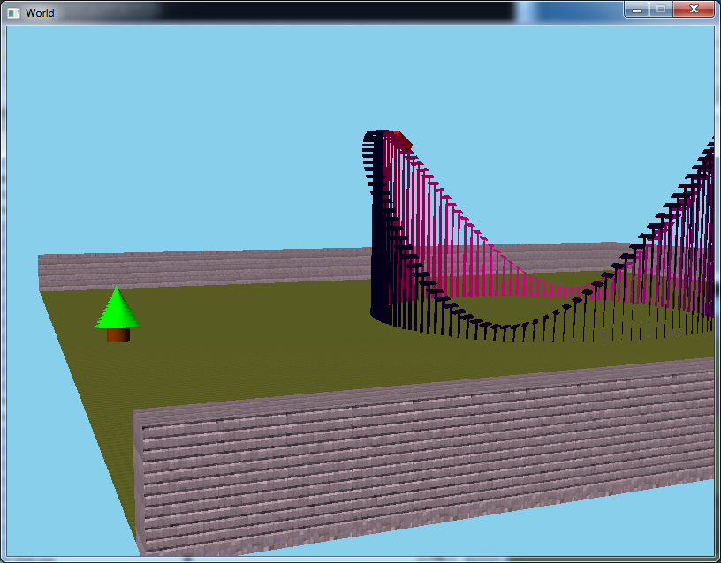
Texture Mapping 20 Points Total: 110 points
Brick Wall with texture applied to all sides

